**Step 1: Install Visual Studio Code (VS Code)**

VS Code will allow you to view and edit files if needed.

1. **Download**: Go to [VS Code’s official website](https://code.visualstudio.com/) and download the version suitable for your operating system.
2. **Install**: Open the downloaded file and follow the instructions to install VS Code.

**Step 2: Install Anaconda (for Conda Environments)**

Conda helps us manage the packages and dependencies for the chatbot’s code.

1. **Download Anaconda**: Visit the Anaconda website and download Anaconda.
2. **Install Anaconda**: Open the downloaded file and follow the instructions.

Installing on Windows/ Mac/ Linux: <https://www.anaconda.com/download/success>

**Step 3: Getting started with VS Code**

1. **Open VS Code**: After downloading, open VS Code by double-clicking its icon.
2. **Install Recommended Extensions**: When you open VS Code for the first time, it may suggest popular extensions to install. Choose any that seem helpful for beginners, or you can skip them for now.
3. **Install Essential Extensions for Coding:**

• **Python Extension** (if you plan to code in Python):

* Click on the "Extensions" icon on the left sidebar (it looks like four squares).
* Search for "Python" and install the official extension by Microsoft. This extension is essential for running Python code.

• **Code Runner**: This extension makes it easy to run code directly in VS Code. Install it by searching for "Code Runner" in Extensions.

**Step 4: Set Up a Python Environment**

1. **Download Python** (if you haven’t already): Go to the [Python website](https://www.python.org/downloads/) and install the latest version (I recommend 3.11).
2. **Verify Python Installation**:

* Open VS Code and go to Terminal -> New Terminal.
* Type python --version to confirm Python is installed. It should show the version number if it's successful.

1. **Select the Python Interpreter in VS Code**:

* Press Ctrl + Shift + P (or Cmd + Shift + P on Mac).
* Type "Python: Select Interpreter" and select the Python version you installed.

**Step 5: Open VS Code and Set Up Conda Environment**

With VS Code installed, open it and follow these steps:

1. **Open Terminal**:
   * Go to **View** -> **Terminal** in VS Code.

* + This opens a command line window where you can enter commands.

1. **Create a Conda Environment**:
   * Type the following command in the terminal and press Enter:

***conda create -n chatbot_env python=3.11***

* + This will create a Conda environment named chatbot_env with Python 3.11 (a compatible version for the code).

1. **Activate the Conda Environment**:
   * Type the command below and press Enter to activate the environment:

***conda activate chatbot_env***

**Step 6: Install Required Packages**

Next, install the packages listed in requirements.txt.

1. **Navigate to the Folder with Requirements**:
   * In the terminal, navigate to the folder where you saved the chatbot files. If the folder is located, for example, in Documents, you can use (please put all the material in one folder, for example, I put all the documents in a folder named Hope 图形用户界面, 文本

2. Open Folder in VS Code:

* Please open the folder where you store all the documents, you need to press file to find out

open folder.

* Please open the folder where you store all the documents, for example, after I open the folder Hope, I can see all the documents about HopeBot. 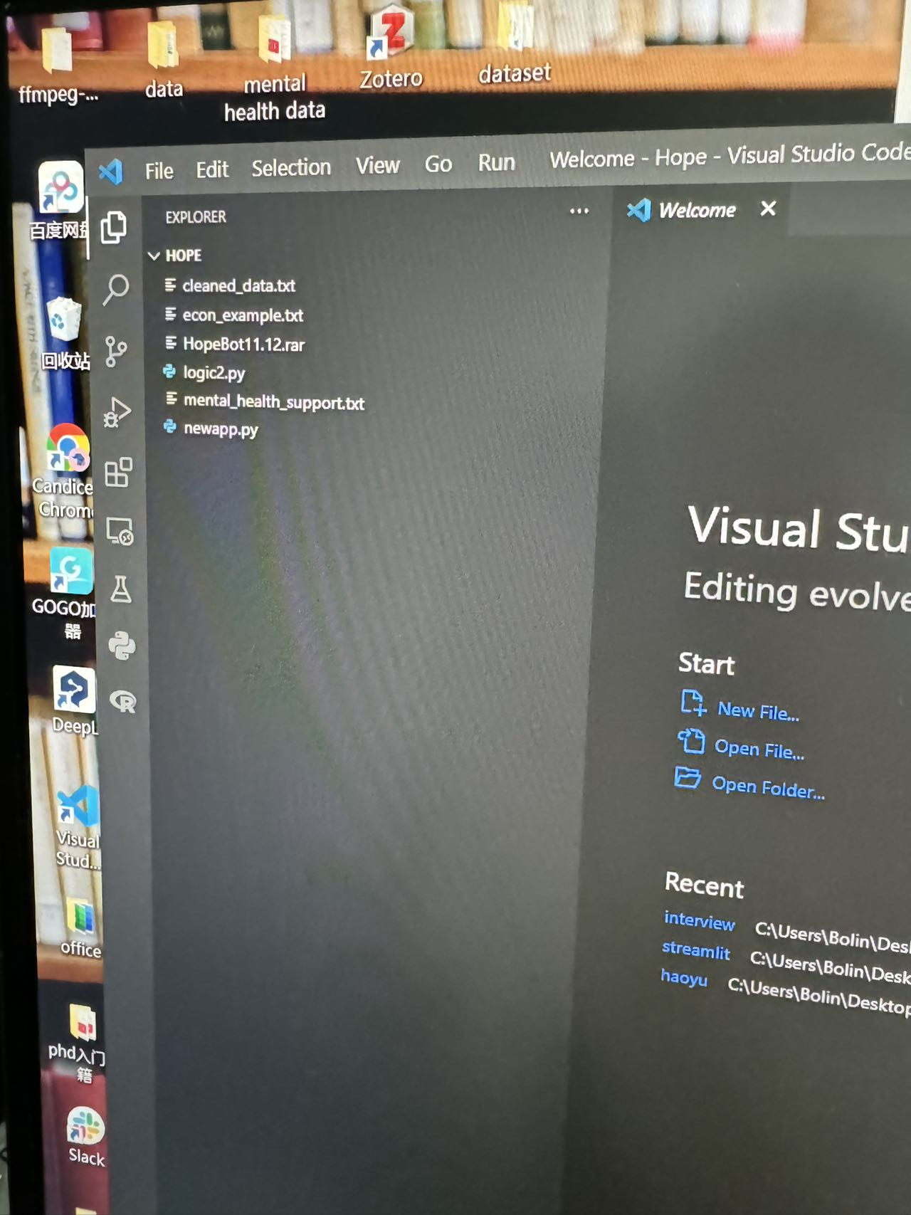

You can open ‘logic2.py’ and press run code, but it will fail because we need to set up the environment before we start.

1. **Install Packages**:

**Important Note**: Sometimes packages conflict with each other, so if one package fails to install, try installing them one by one.

• **Open the Terminal in VS Code**:

* At the top of VS Code, click **Terminal**, then **New Terminal**.
* A new section will open at the bottom of the screen; this is the terminal where you can type commands.

• **Navigate to the Folder in the Terminal**:

* To make sure you’re in the correct folder, type cd (don’t press Enter yet).
* Go to the left sidebar in VS Code, right-click your folder (e.g., HopeBot), and select **Copy Path**. 电脑屏幕的照片上有文字

  描述已自动生成
* Paste the path in the terminal after cd and press Enter.

• **Install Packages from requirements.txt**:

* In the terminal, type the following command and press Enter:

***pip install -r requirements.txt***

* This command installs packages listed in requirements.txt.
* **If there are errors** saying some packages can't install, try installing them individually as explained next.

**Manually Install Individual Packages**:

* If certain packages didn’t install, try installing each one by typing:

***pip install openai dotenv langchain langchain_openai langchain_community streamlit audio_recorder_streamlit chromadb streamlit_chat audio_recorder_streamlit streamlit_float***

Type each package separately if you run into problems with conflicts.

***•***

**Step 7: Modify File Paths in logic2.py**

• **Open logic2.py**:

* In the VS Code sidebar, find logic2.py and click it to open.

• **Check File Paths**:

* Look through logic2.py for any file paths, like ones referring to folders cleaned_data, econ_example, and mental_health_support.
* Ensure these paths match the location of these folders in HopeBot in your pc. Copy your path of cleaned_data, econ_example, and mental_health_support, replace them in your code, and keep the others the same.

**Step 8: Run the Chatbot Code**

1. **Run newapp.py**

You should make sure everything is with logic2.py can be run smoothy, and then you should open newapp.py.

If you see the output be like that, it means everything can work.

And then you should press run the code to run newapp.py

1. **Launch the Streamlit App**:
   * Finally, to open the interactive chatbot interface, run:

cd C:\path of your folder (for example, in my pc, I enter:

***cd C:\Users\Bolin\Desktop\hope***)

**streamlit run app.py**

* + This command will open a web page on your browser, where you can interact with the chatbot on a local server.